ShopEZ — Full Stack E-Commerce Platform
Project Documentation (MERN Stack) Version 1.0
1. Introduction
Project Title
- ShopEZ – A Full-Stack E-Commerce Platform built on the MERN stack
Team Members
- Gandla Maldakal Harini — Built the entire application, including the React frontend, Node/Express backend, database design, authentication, and deployment
- Sriram Koppula — Team Leader : prepared the project documentation
2. Project Overview
Purpose
- A full-stack e-commerce web app built using MongoDB, Express.js, React, and Node.js
- Supports four user roles: customer, seller, delivery manager, and admin, each with its own interface
- Covers the complete shopping journey: browsing products, cart, checkout, payment, order fulfilment, and support
Key Features
- Customer: search by category or keyword, price filters, flash deals, trending products, product pages with reviews, cart and wishlist, Razorpay and mock-card checkout, order tracking, price-drop alerts, reorder reminders, support tickets, and password reset via email
- Seller: dashboard for listings, stock, and orders; product creation with custom specifications; inventory management
- Delivery Manager: view assigned orders and update shipment status (packed, shipped, delivered)
- Admin: view platform stats, manage categories, manage users, oversee orders, and handle support tickets
3. Architecture
Frontend
- Built with React 19 and Vite as a single-page application
- Uses React Router v7 for navigation and React Bootstrap for UI components
- State is managed with React Context (Auth, Cart, Wishlist) and custom hooks (useCart, useWishlist, useOrders, useProducts)
- API calls are organised in a dedicated api/ folder, one file per feature area, using Axios
- Axios automatically refreshes expired login tokens
- A ProtectedRoute component restricts pages based on user role
Backend
- A REST API built with Node.js and Express 5, using ES Modules
- Organised into routes, controllers, and services for clean structure
- express-validator checks incoming requests; a central error handler keeps error responses consistent
- Background jobs (node-cron) run every 12 hours for price-drop alerts and reorder reminders
Database
- MongoDB is the main database, accessed through Mongoose 9
- Core models: User, Product, Category, Cart, Wishlist, Order, Payment, and Review
- A seed script creates sample categories, products, and test accounts for local development
4. Setup Instructions
Prerequisites
- Node.js 18 or later
- MongoDB (local or MongoDB Atlas)
- A Razorpay account (test keys work fine for local setup)
Installation Steps
- Clone the repository: git clone https://github.com/Harini-7228/ShopEZ.git
- Set up environment files by copying server/.env.example and client/.env.example
- Add MongoDB URI, JWT secrets, and Razorpay keys to server/.env
- client/.env works by default with VITE_API_URL=/api/v1 for local use
- Install dependencies in both server and client folders using npm install
- Run npm run seed in the server folder to create sample categories, products, and test accounts
5. Folder Structure
Client (React + Vite)
- api/ — one file per feature area (auth, products, orders, and so on)
- components/ — shared components (Layout, Navbar, Footer, Sidebar, ErrorBoundary) and product components (ProductCard)
- context/ — Auth, Cart, and Wishlist context providers
- hooks/ — useCart, useWishlist, useOrders, useProducts
- pages/ — role-based pages (admin, delivery, seller) plus Home, ProductList, ProductDetail, Cart, Checkout, OrderHistory, ForgotPassword, and more
- routes/ — ProtectedRoute for role-based access
- utils/ — helper functions such as productVariants
Server (Node.js + Express)
- config/ — database, environment, and Razorpay setup
- controllers/ — one file per feature area
- jobs/ — scheduled tasks for price alerts and reorder reminders, run every 12 hours
- middleware/ — authentication, error handling, and request validation
- models/ — User, Product, Category, Cart, Wishlist, Order, Payment, Review
- routes/ — all mounted under /api/v1/
- scripts/ — database seeding and image update scripts
- services/ — business logic for checkout, auth, orders, reviews, and seller functions
- utils/ — helper functions for tokens, API responses, coupons, and async handling
6. Running the Application
- Frontend and backend run as two separate processes
- Backend: run npm run dev in the server folder — starts the API at http://localhost:5000
- Frontend: run npm run dev in the client folder — starts the app at http://localhost:5173
- Test accounts (all use password "123456"): customer@shopez.com, seller@shopez.com, delivery@shopez.com, admin@shopez.com
7. API Documentation
- Base URL for local development: http://localhost:5000/api/v1
- All requests and responses use JSON format
- Protected routes need a valid access token, sent automatically through a secure cookie
Main Route Groups
Route | Purpose
/auth | Register, login, logout, refresh token, password reset
/products | Browse, search, and filter products
/categories | Category listing and hierarchy
/cart | Cart operations (add, update, remove)
/wishlist | Wishlist management
/orders | Checkout, order history, and status updates
/payments | Razorpay order creation and payment check
/reviews | Product reviews
/alerts | Price-drop and back-in-stock alerts
/reorders | Reorder reminders
/coupons | Available coupon codes
/seller | Seller dashboard and product management
/admin | Admin panel operations
/support | Support tickets

Example: Creating an Order (POST /orders)

- Request: cartId, addressId, and an optional couponCode
- Response: confirms success and returns the new orderId with status "placed"
Coupons
- SAVE10 — 10% off on orders above ₹500
- SHOPEZ15 — 15% off on orders above ₹3000
8. Authentication
- Uses JSON Web Tokens (JWT) for login sessions
- On login, the server issues a short-lived access token and a longer-lived refresh token
- Both tokens are stored in secure, HttpOnly cookies so client-side scripts cannot access them
- Passwords are hashed with bcrypt before being saved
- Axios automatically requests a new access token when the old one expires, keeping the user logged in
- Role-based areas (seller, delivery, admin) are protected on both backend (middleware) and frontend (ProtectedRoute)
- Forgot-password and reset-password work through a time-limited link sent by email
9. User Interface
- Home Page — flash deals, trending products, and category navigation
- Product Detail Page — specifications, reviews, and related products
- Cart and Checkout Flow
- Order History with a live status timeline
- Seller Dashboard
- Delivery Manager Dashboard
- Admin Panel

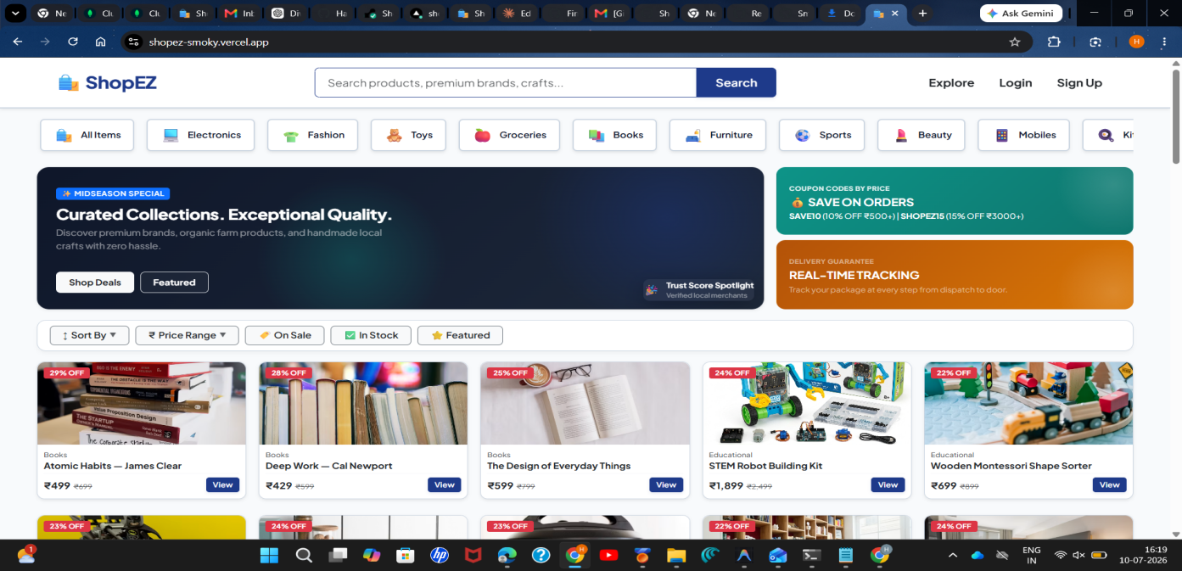

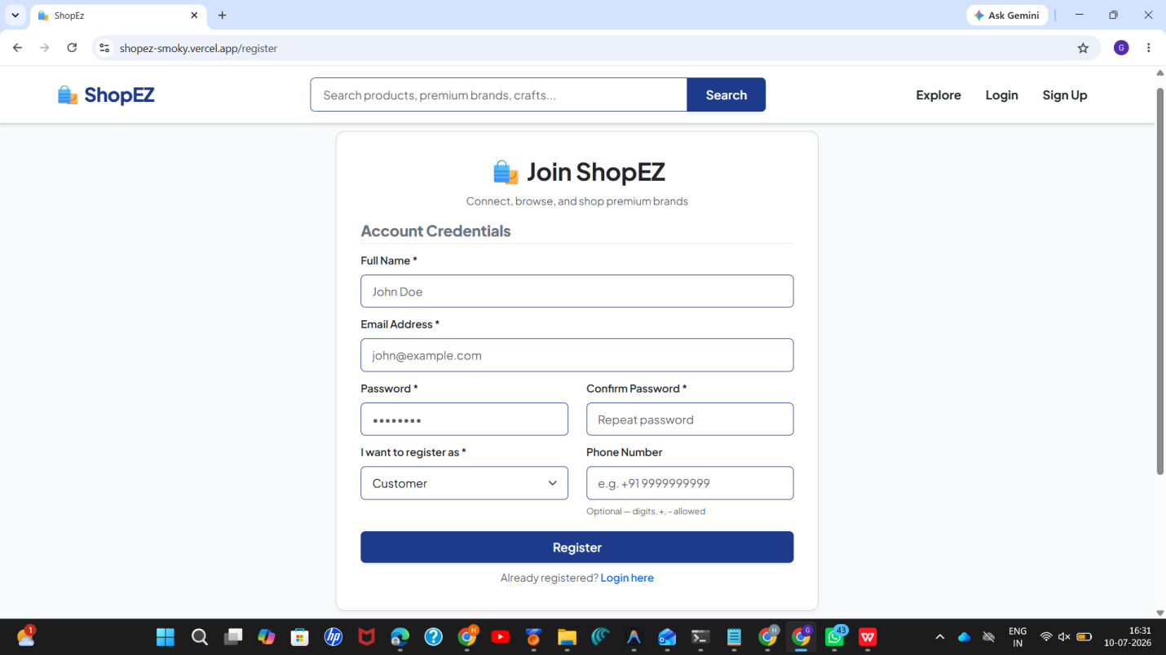

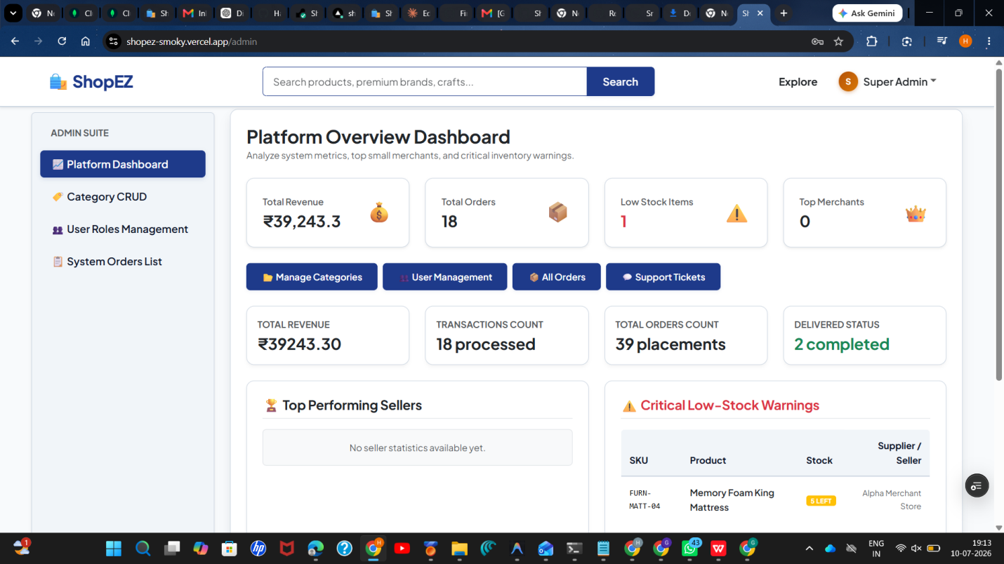

10. Testing
API Testing — Postman
- All REST endpoints tested using saved Postman collections for each feature area
- Covered success cases, validation errors, and access checks for protected and role-based routes
Unit Testing — Jest
- Used to test backend logic such as coupon calculations, order totals, and token utilities
- Helped catch pricing and discount errors early
Manual Testing
- Checked complete flows for all four roles: customer sign-up to checkout, seller product management, delivery status updates, and admin controls
- Cross-browser testing done on Chrome and Firefox
11. Screenshots or Demo
- Live demo available at: https://shopez-smoky.vercel.app
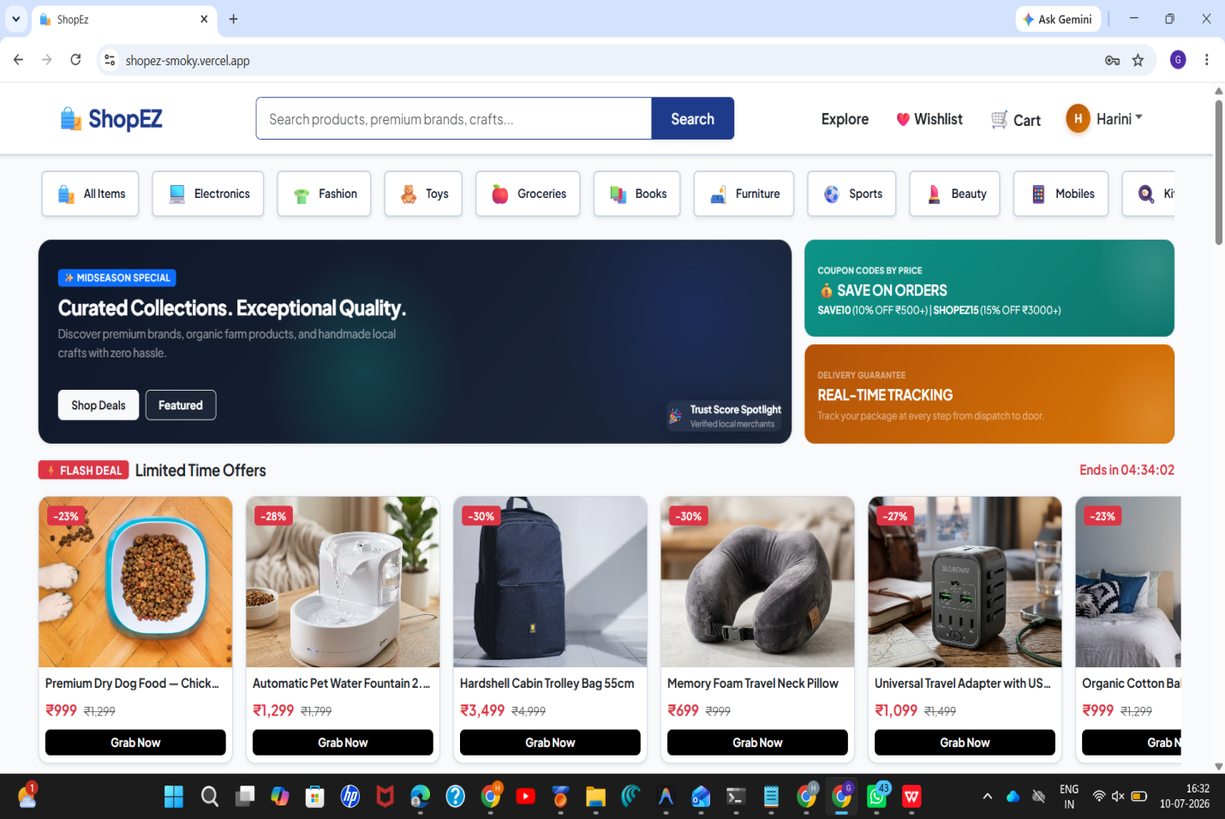

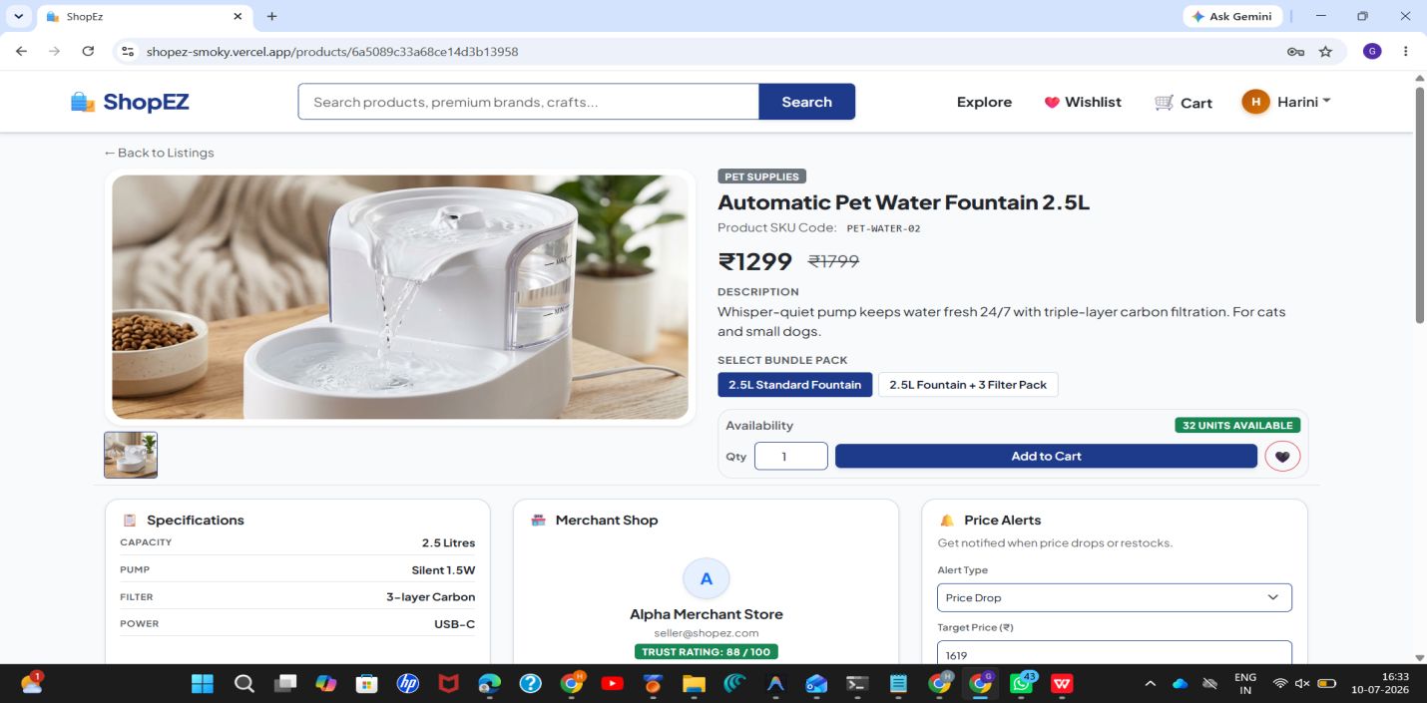

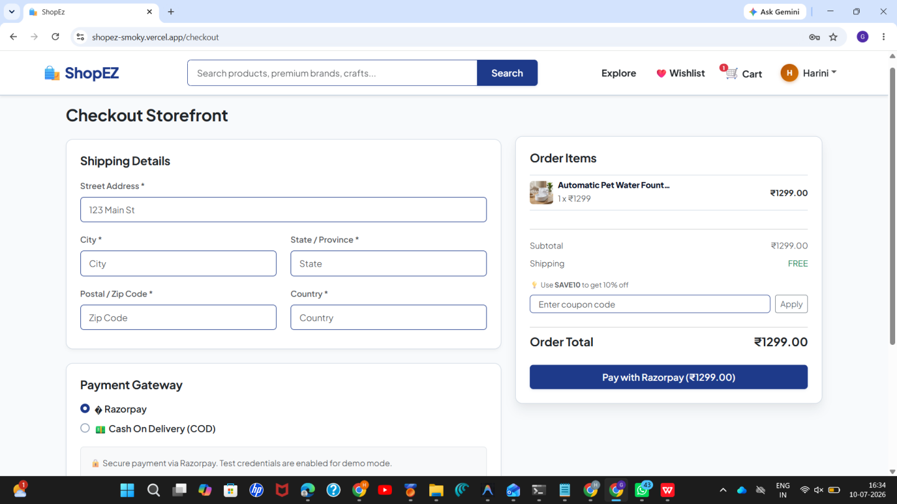

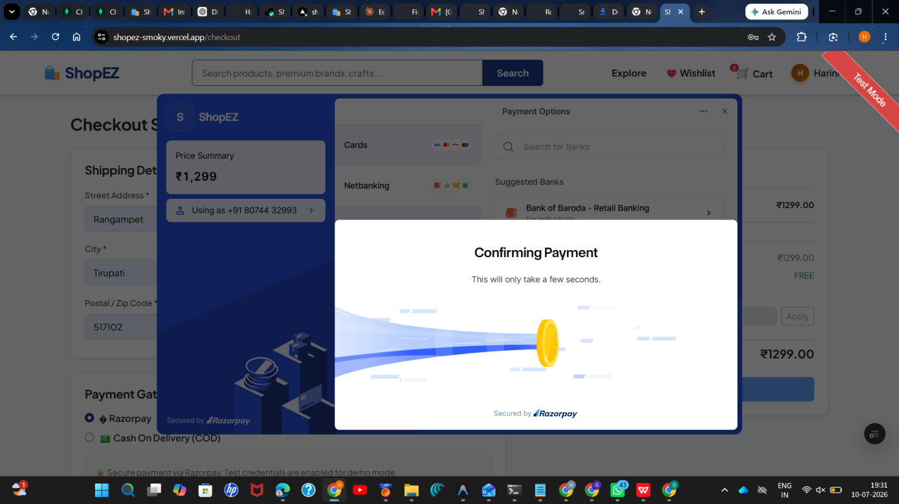

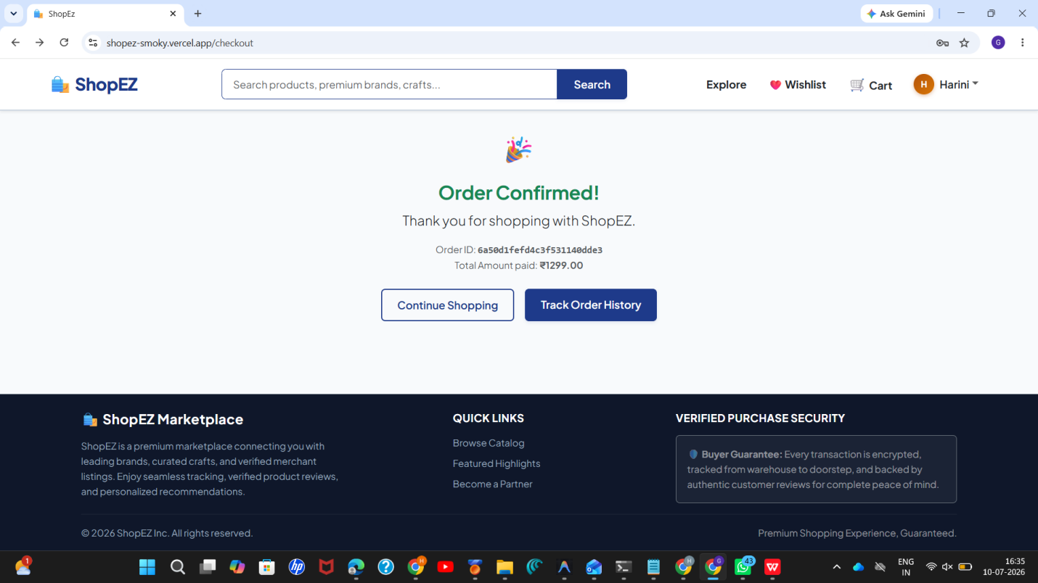
12. Known Issues
- Only Razorpay is supported for payments; no other or international gateway yet
- Order status updates are not real-time; users must refresh to see the latest status
- No automated CI/CD pipeline; deployment to Render and Vercel is done manually
- Product search matches only exact name or category text, without fuzzy or typo-tolerant search
13. Future Enhancements
- AI-powered chatbot for common customer questions, reducing support ticket load
- Gift cards and store credit that can be combined with coupons at checkout
- Social login using Google or Facebook for faster sign-up
- Real-time order tracking using WebSockets instead of manual refresh
- A Progressive Web App (PWA) build for offline use and mobile installability
- Seller-facing analytics for sales trends and best-selling products

